**AWS PROJECT- 1**

**DEPLOYING THREE TIER APPLICATION USING TERRAFORM**

**PREREQUISITES**

* Basic knowledge of aws & terraform
* Aws account
* Iam user
* Github account
* Aws access & secret key

**LIST OF STEPS IN THE PIPELINE**

* + create a file for the vpc
  + Create a file for the subnet
  + Create a file for the internet gateway
  + Create a file for the route table
  + Create a file for the ec2 instances
  + Create a file for the SG for the front end tier
  + Create a file for the application load balancer
  + Create a file for the RDS instance
  + Create a file for outputs
  + Create a file for the variable
  + Create a file for the user data
  + Verify the resources

In this project we will use some variables also that we will discuss here

**Step1: create a file for the vpc**

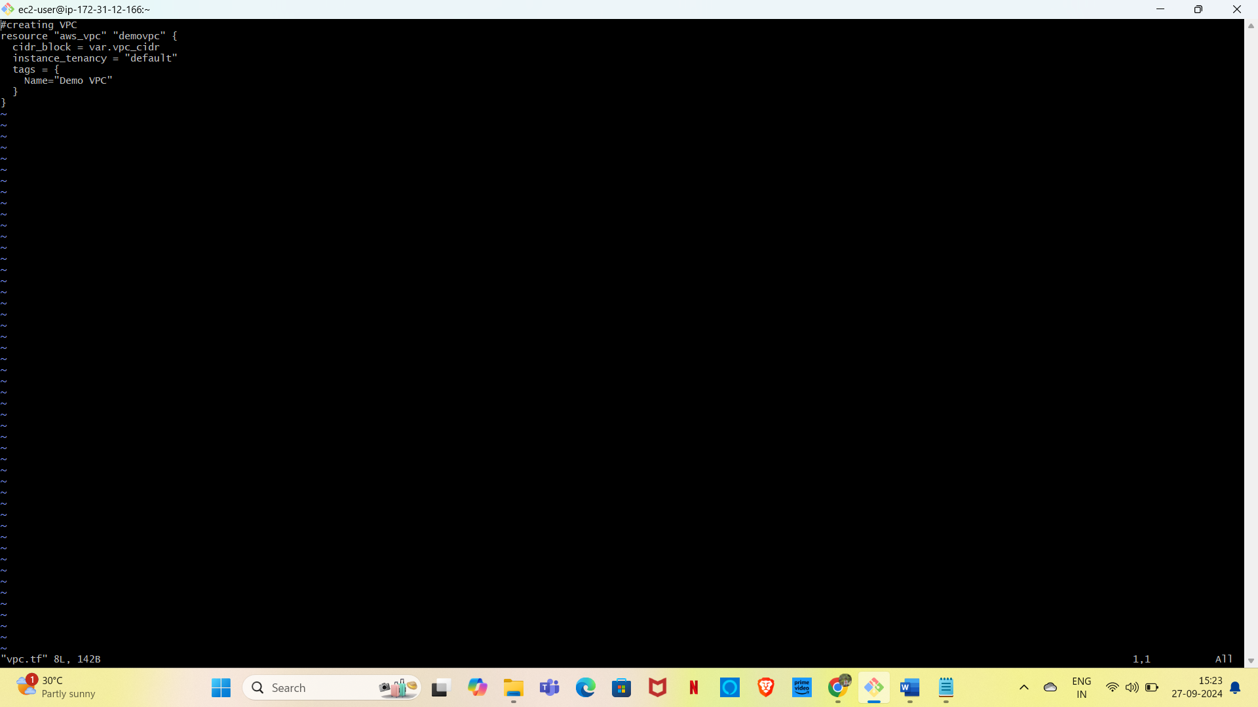

* We can get the vpc and vpc is given below.

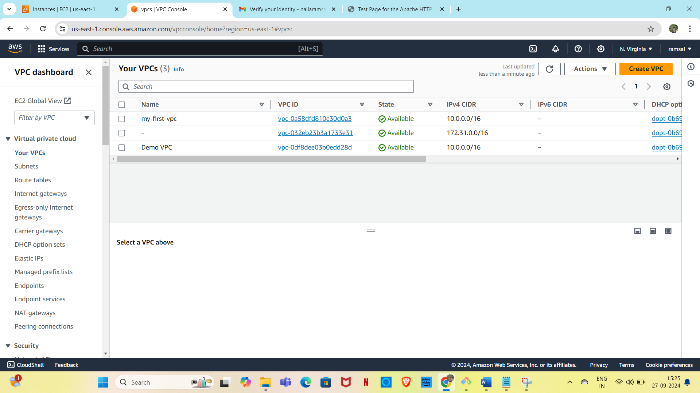

**STEP2**

* For this project, we will create total 6 subnets 4-public 2-private.

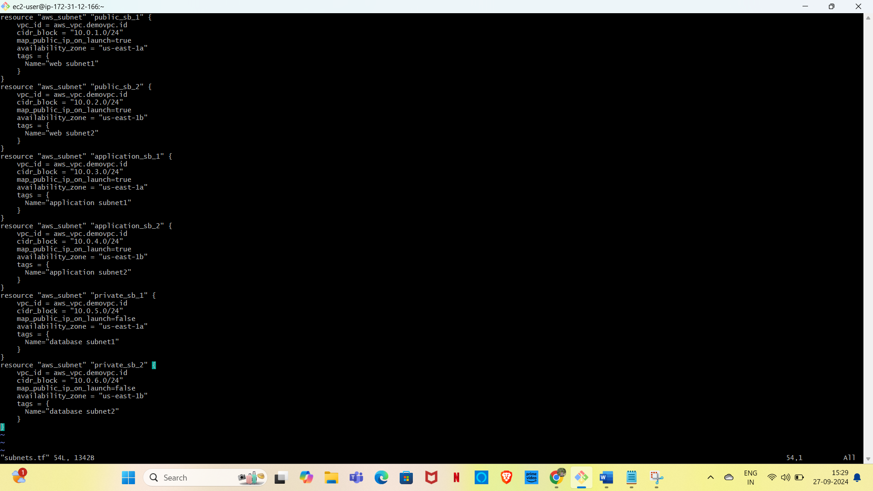

* The console will create the subnets with name demo subnets

. 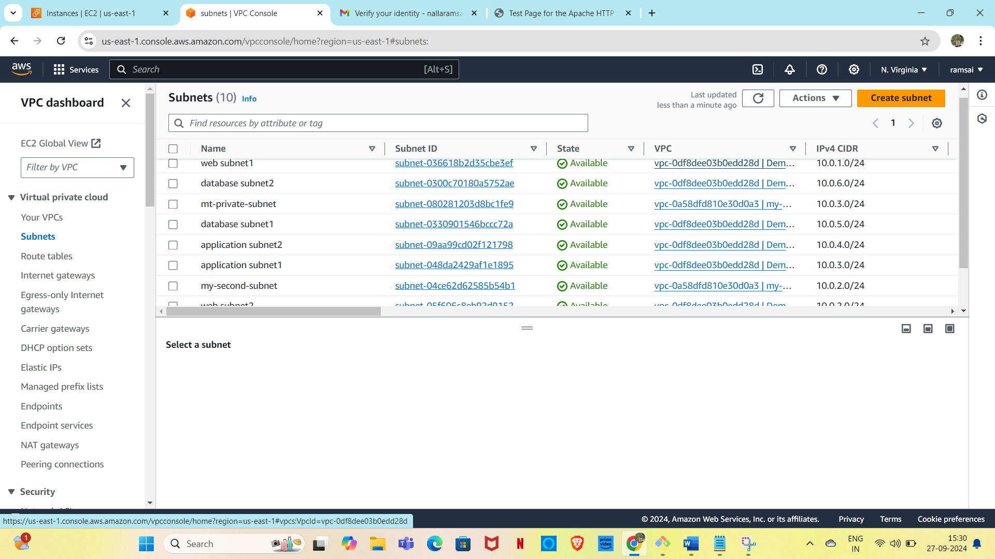

Step-3: **Creating as file for the internet gateway**



* In console it will create new internet gateway as demoVPC.

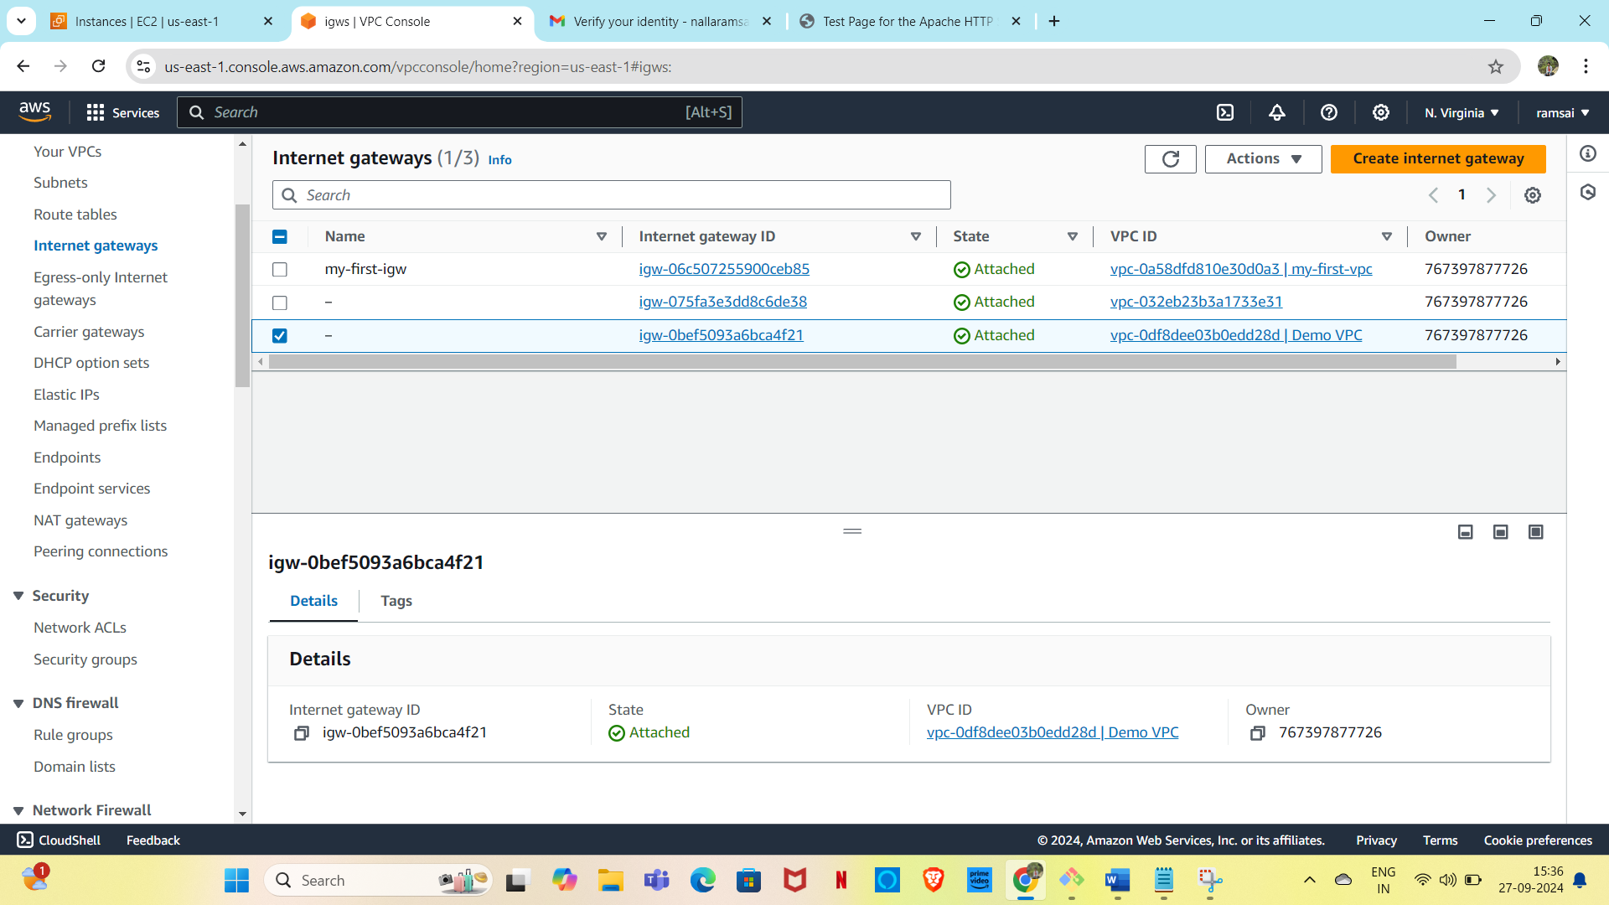

Step-4: **Creating a file for the route table**

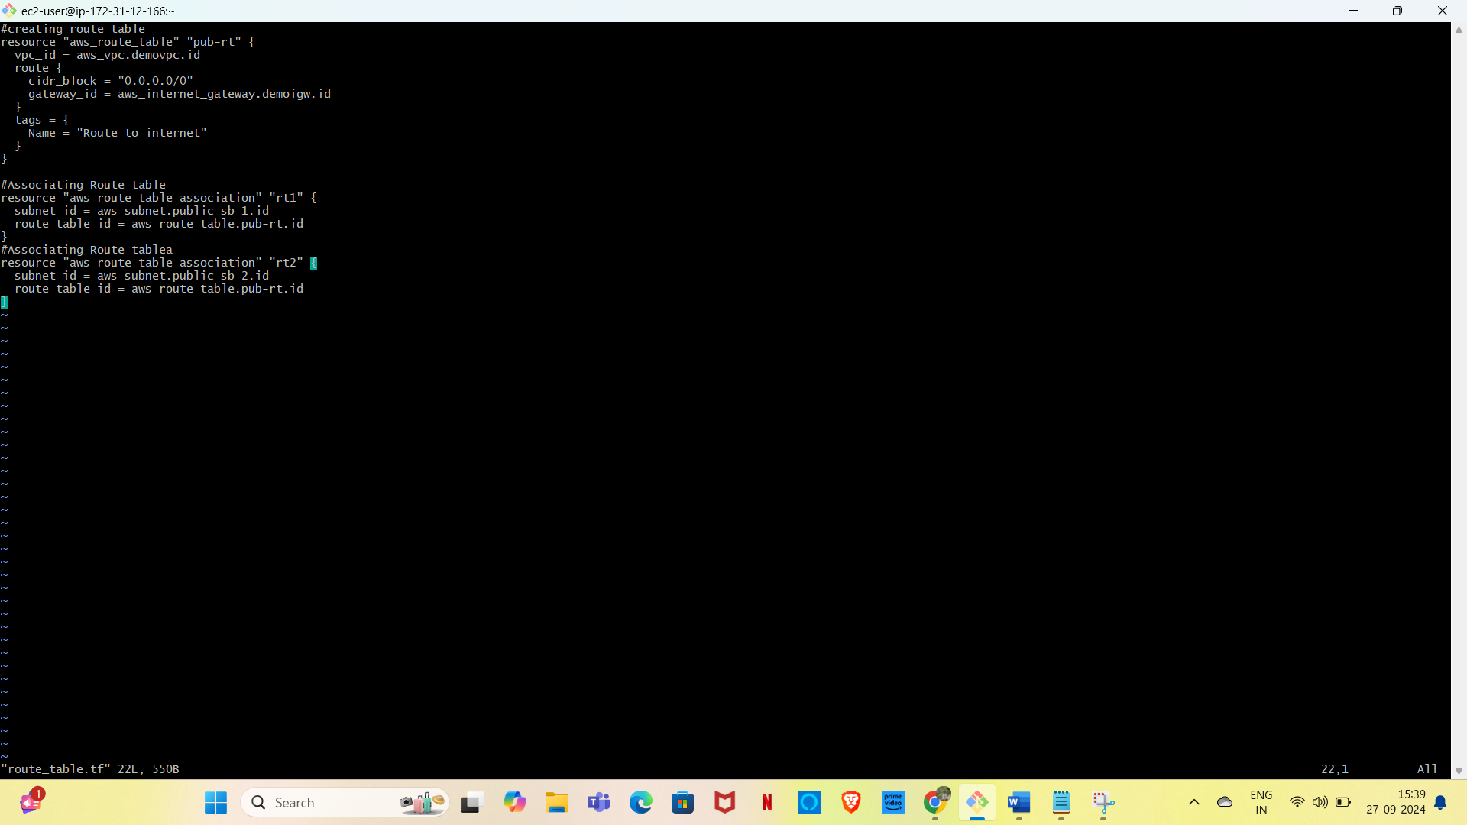

* Some route tables are been created in the below.

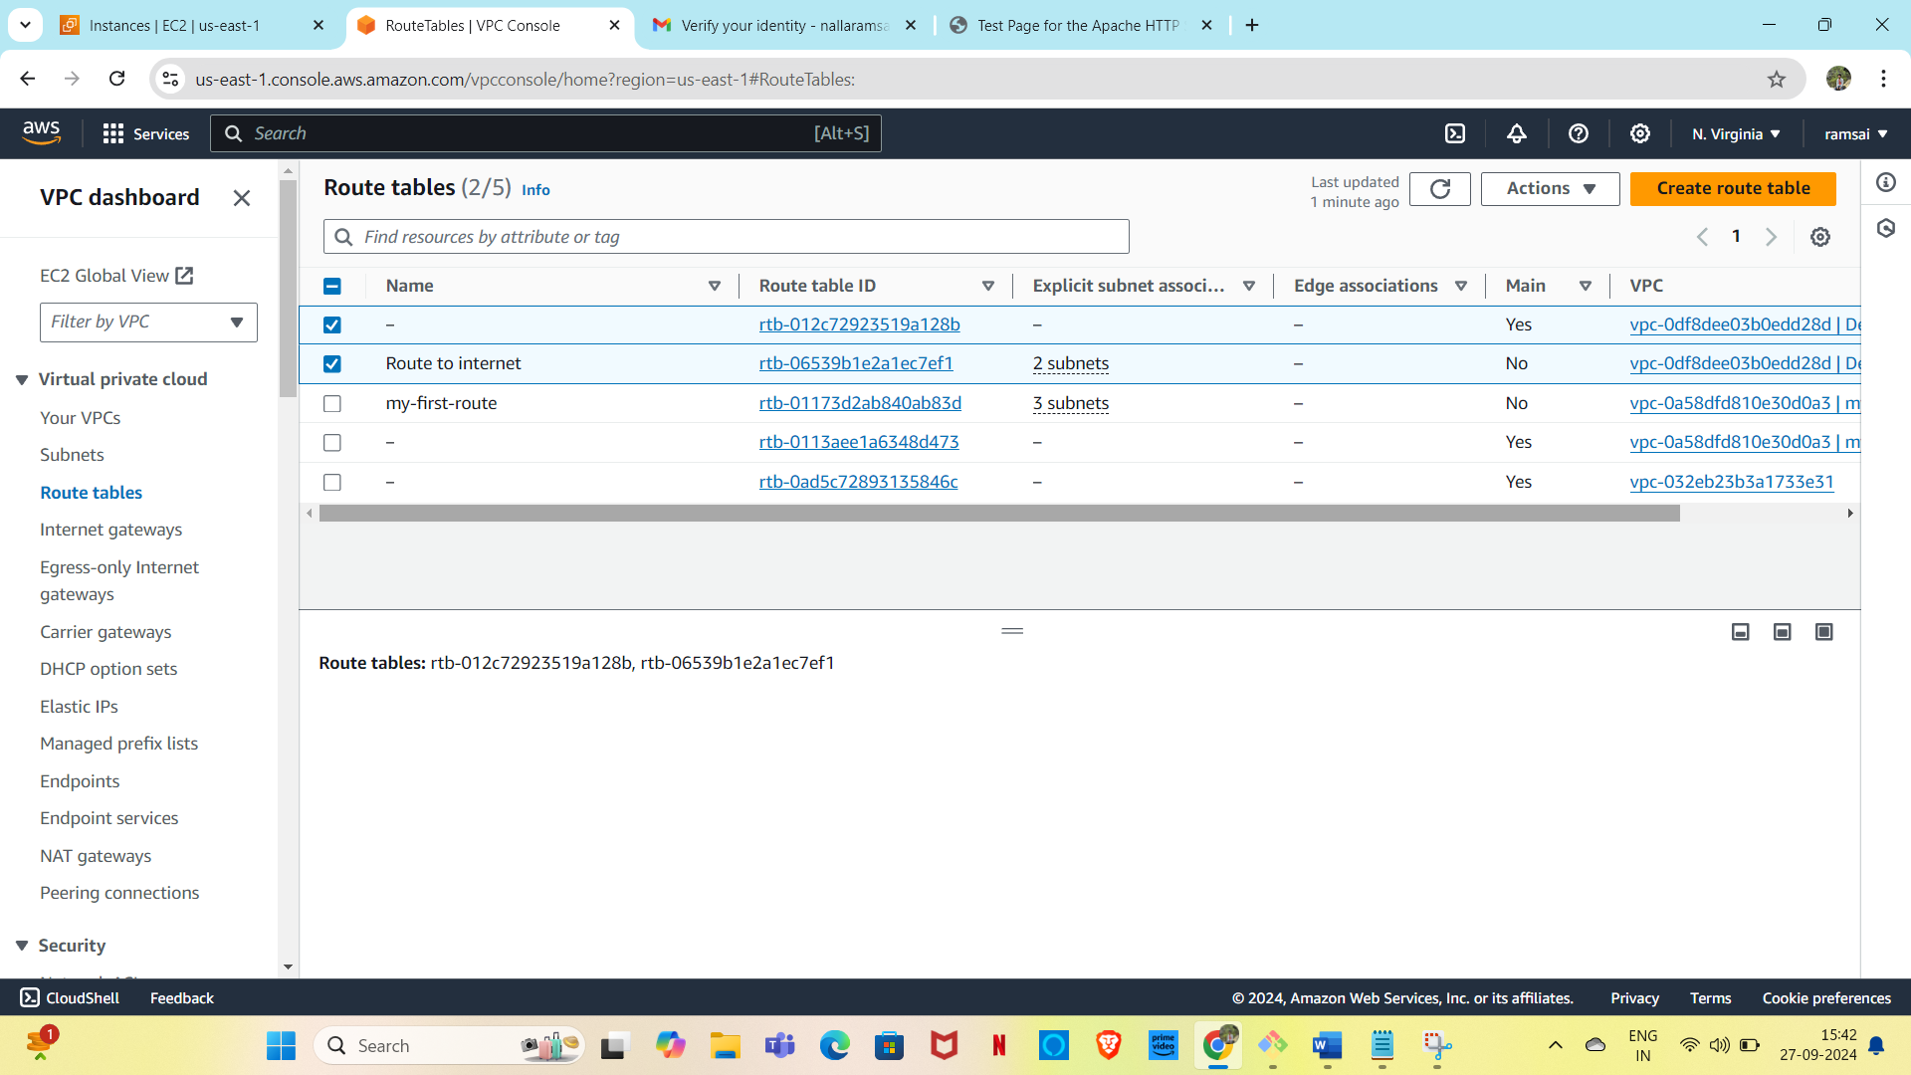

Step-5: **Creating a file ec2 instances**

* **The above figure represents about the 1st instance.**
* 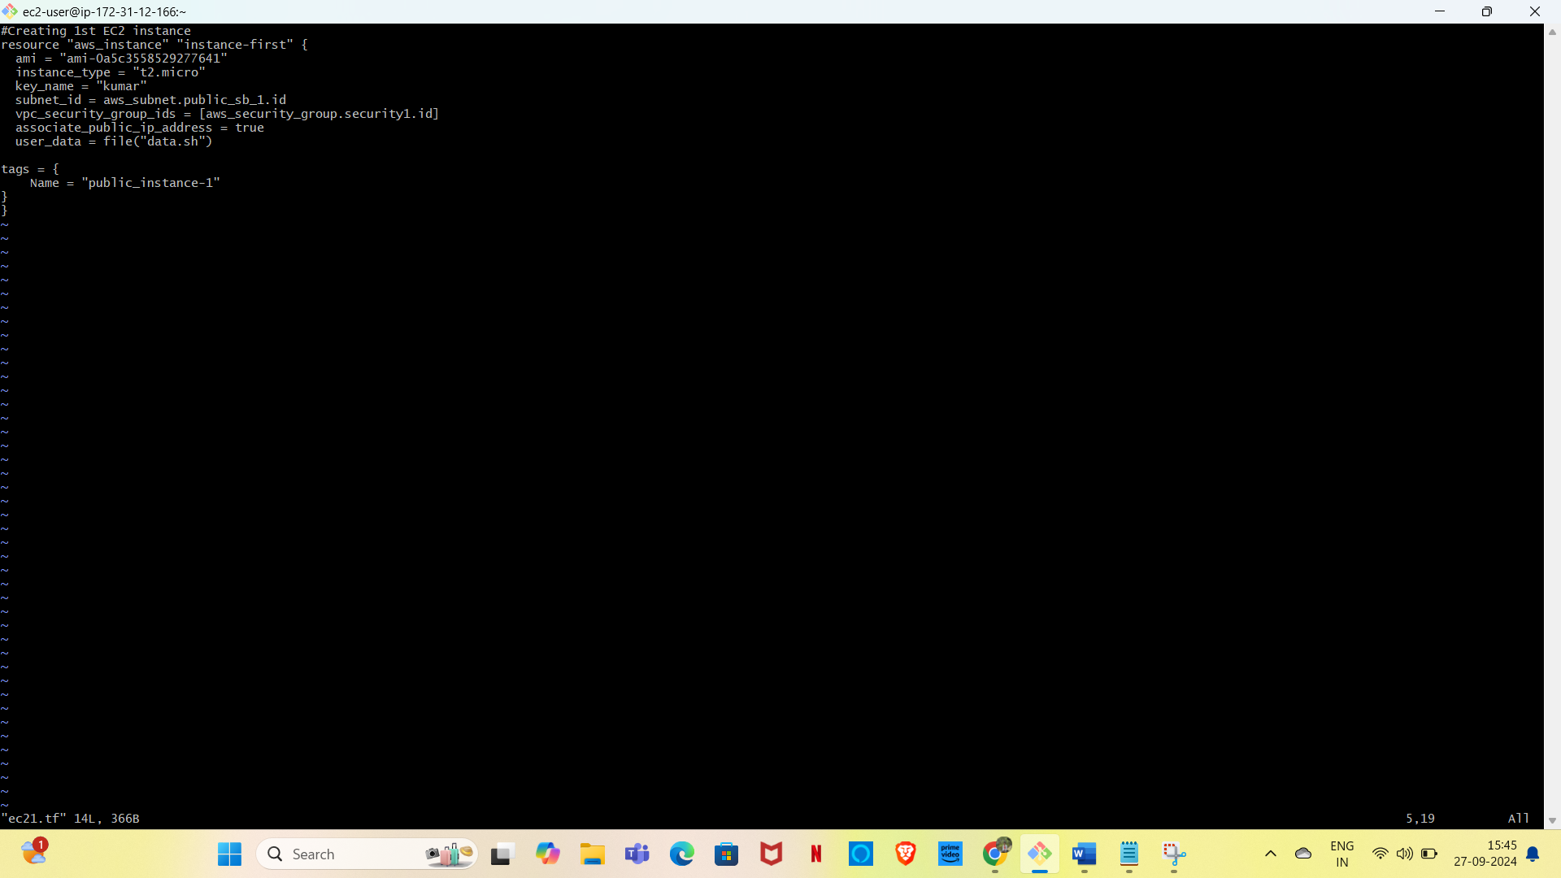
* The second picture represents about the 2nd instance.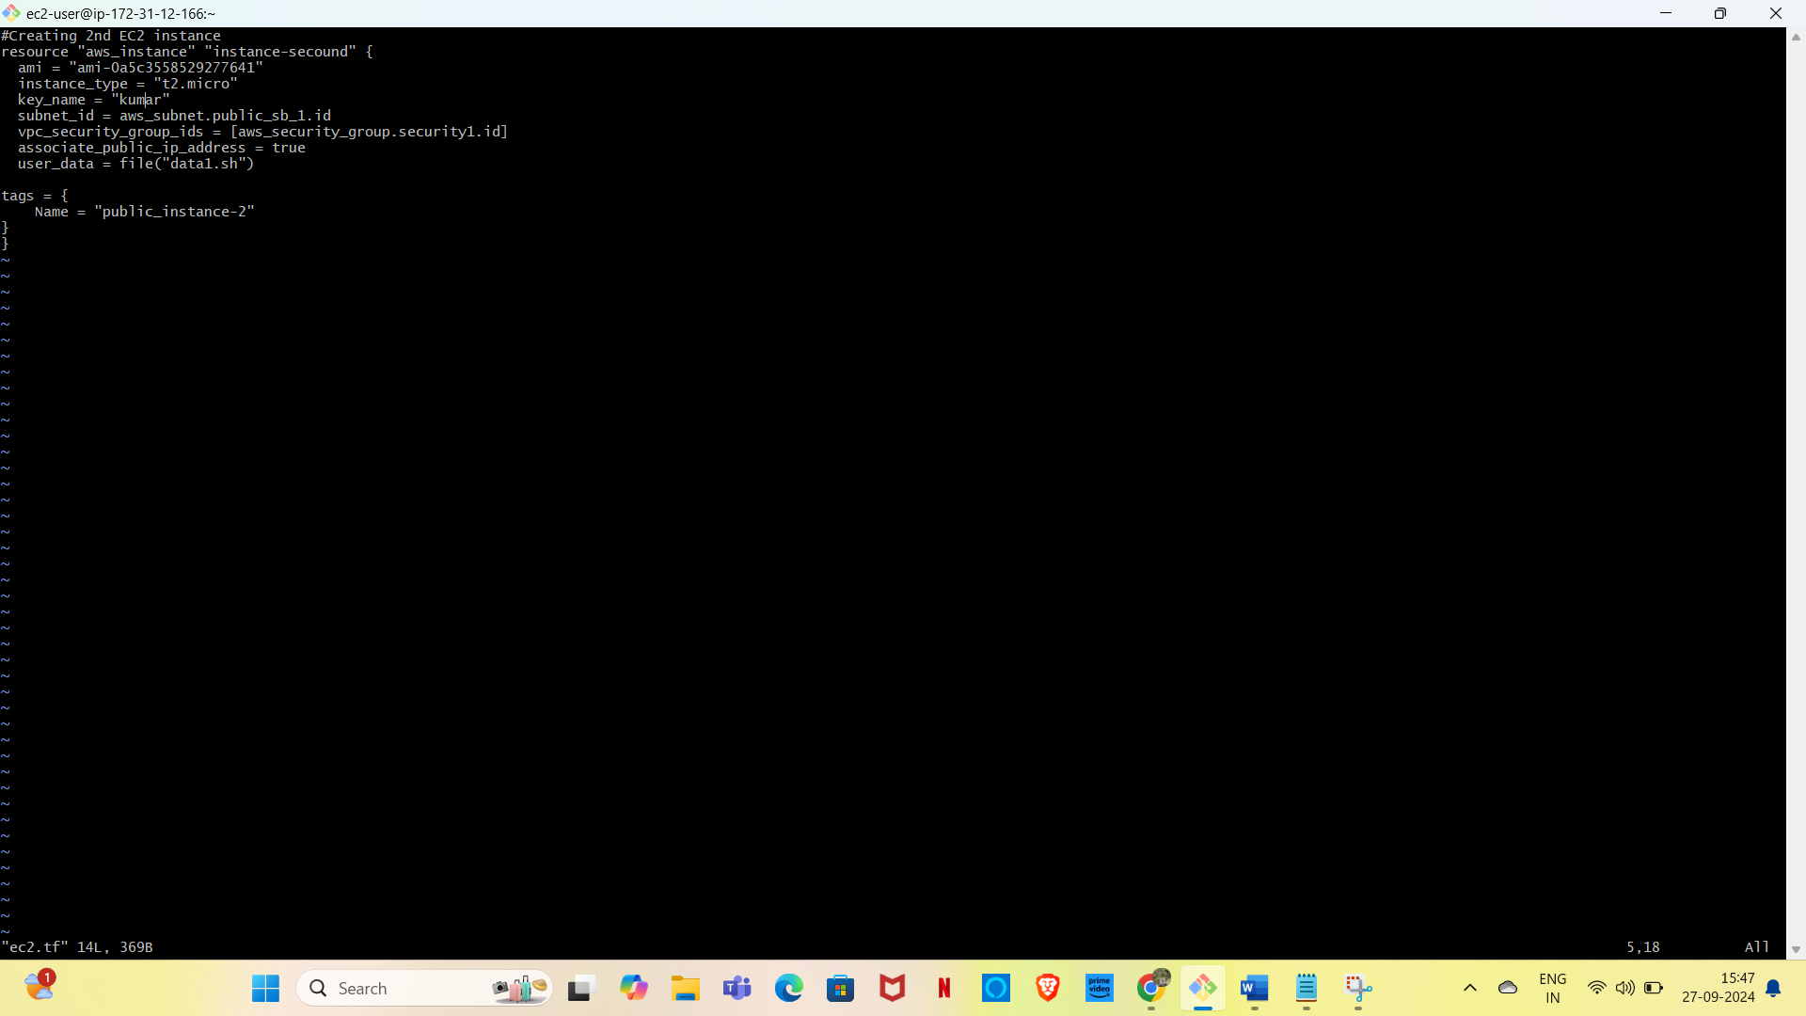
* The two instance are named as public instance, which are represented in the below figure.

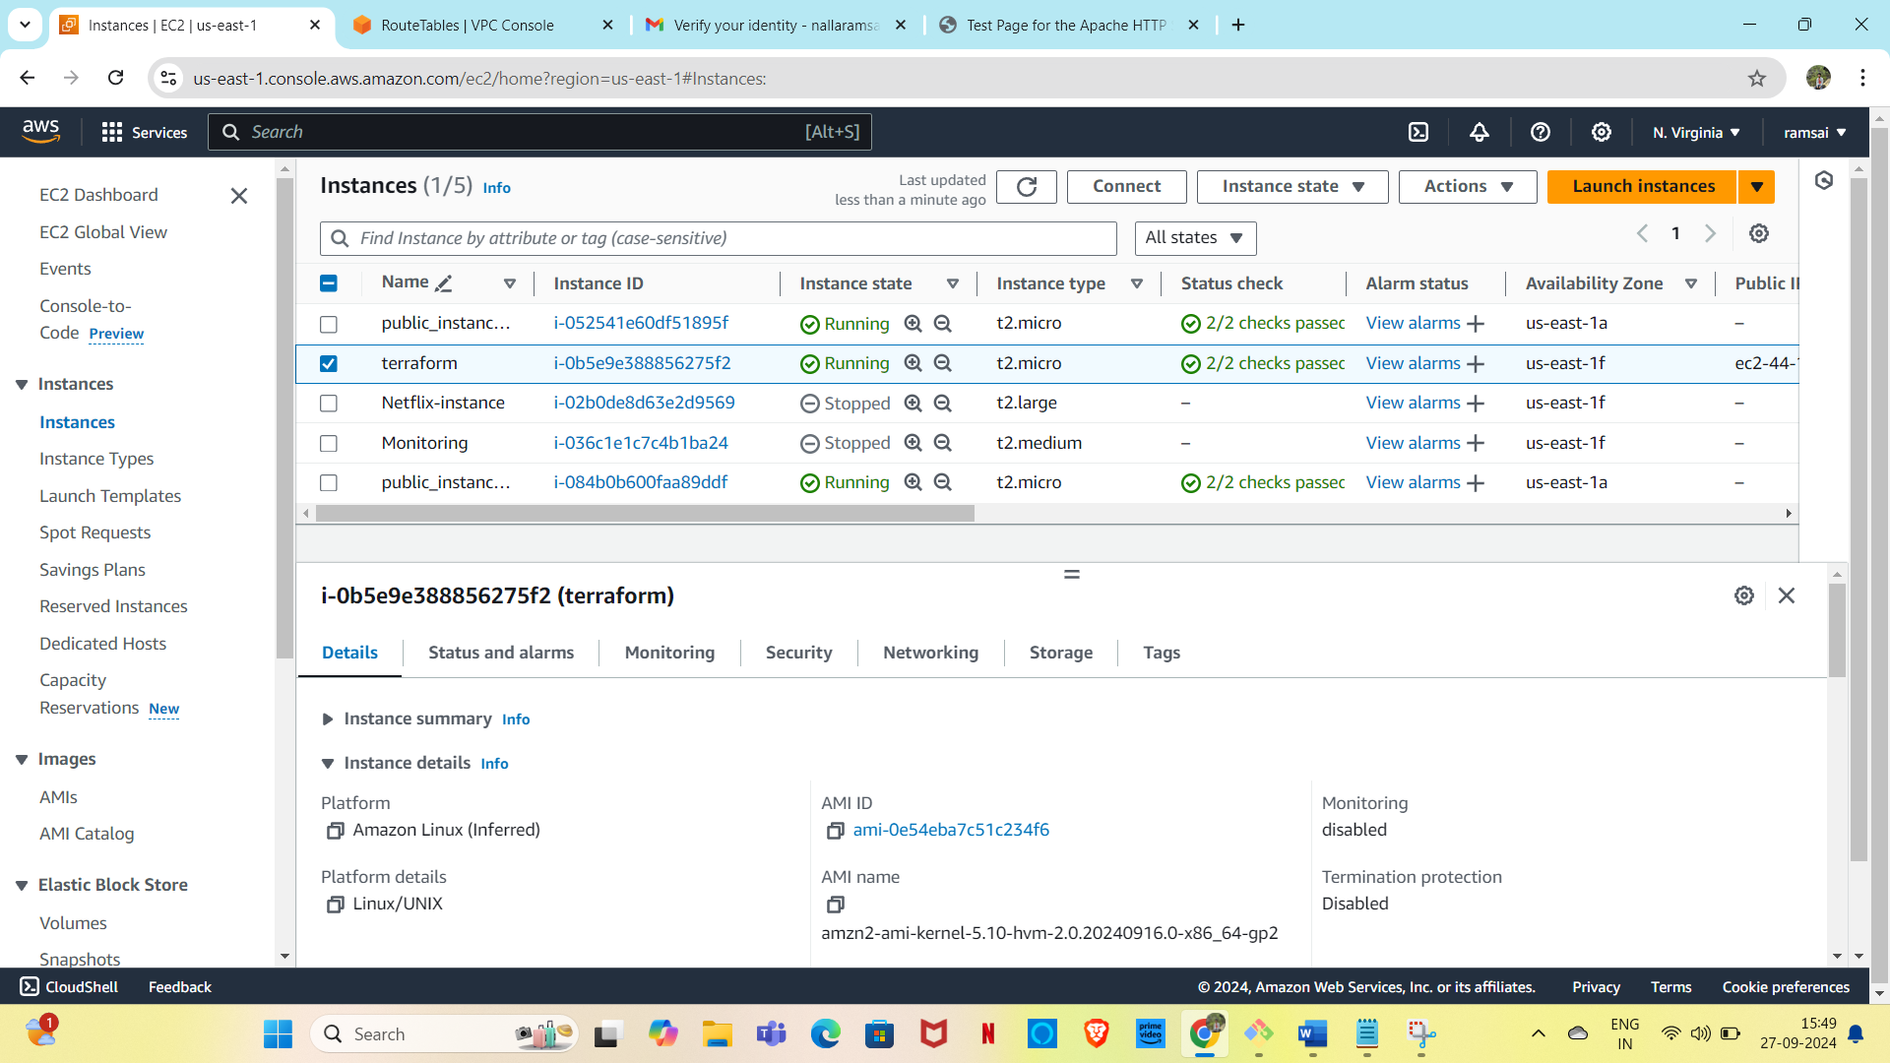

Step-6: **Create a file for the security groups for the front end**

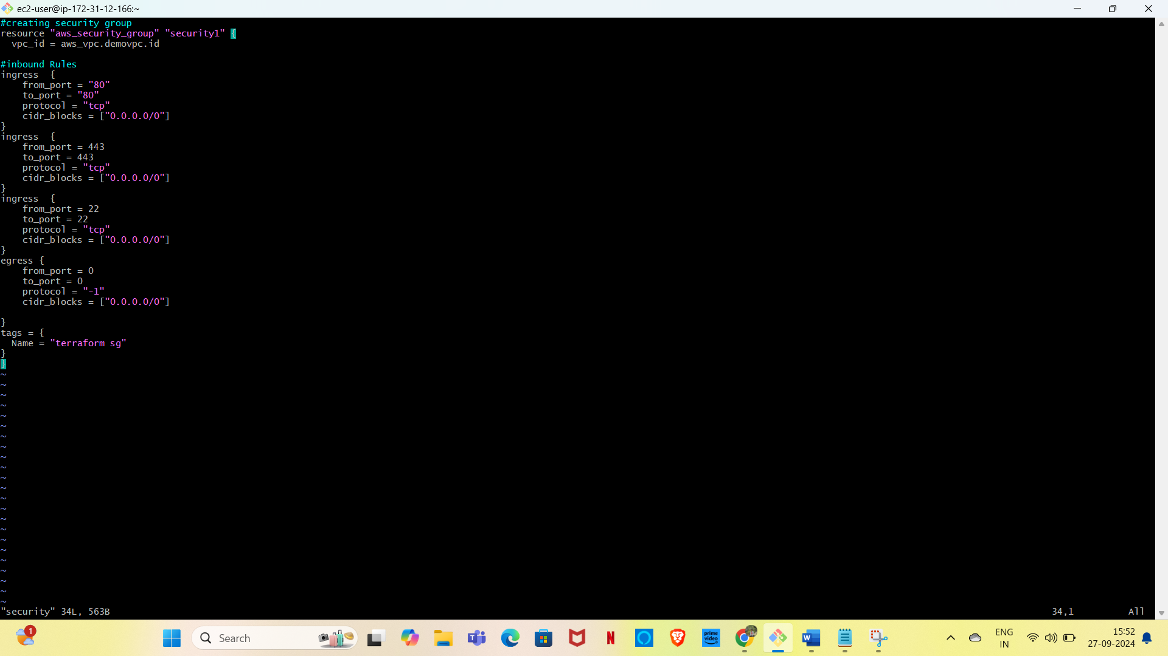

* Two security groups are created with names database security and terraform sg.

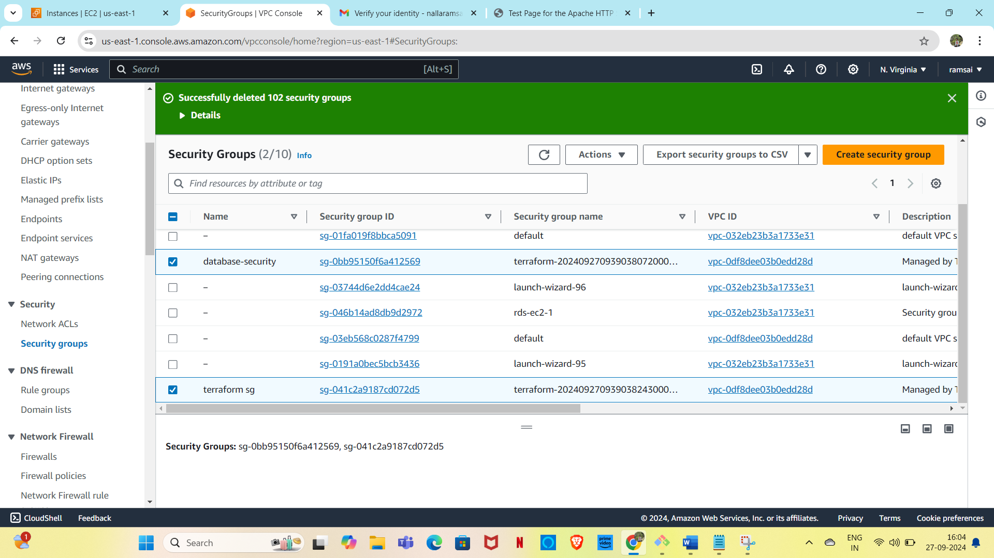

Step-7: **Create a application for load balancer**

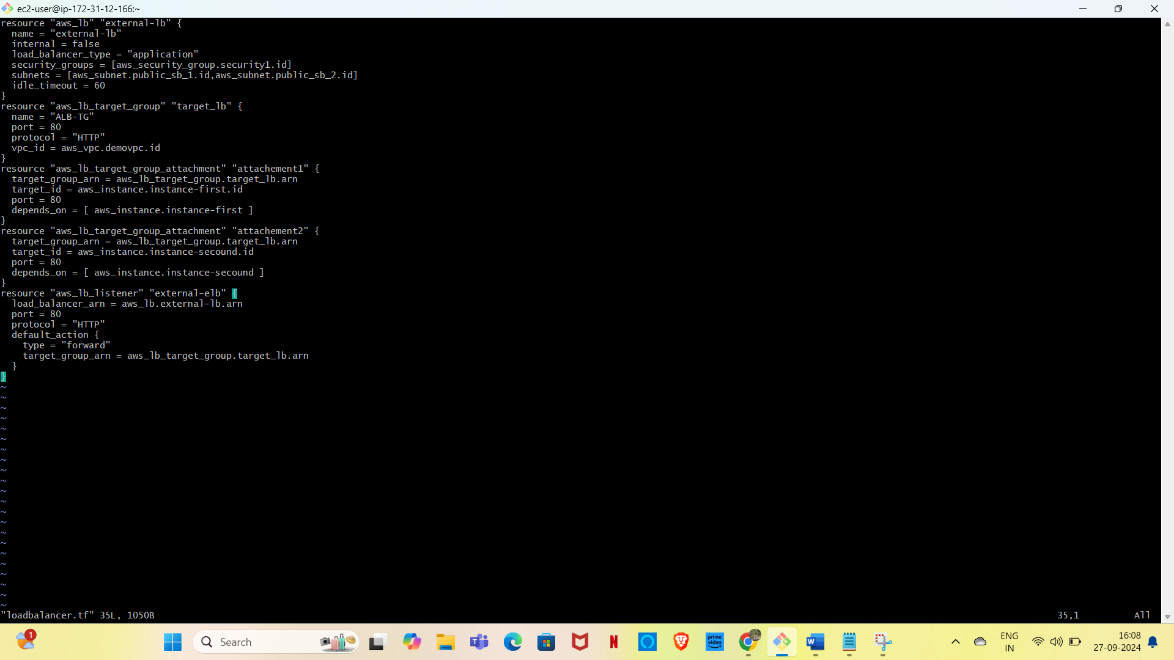

* **One loadbalancer will be created in the below picture.**

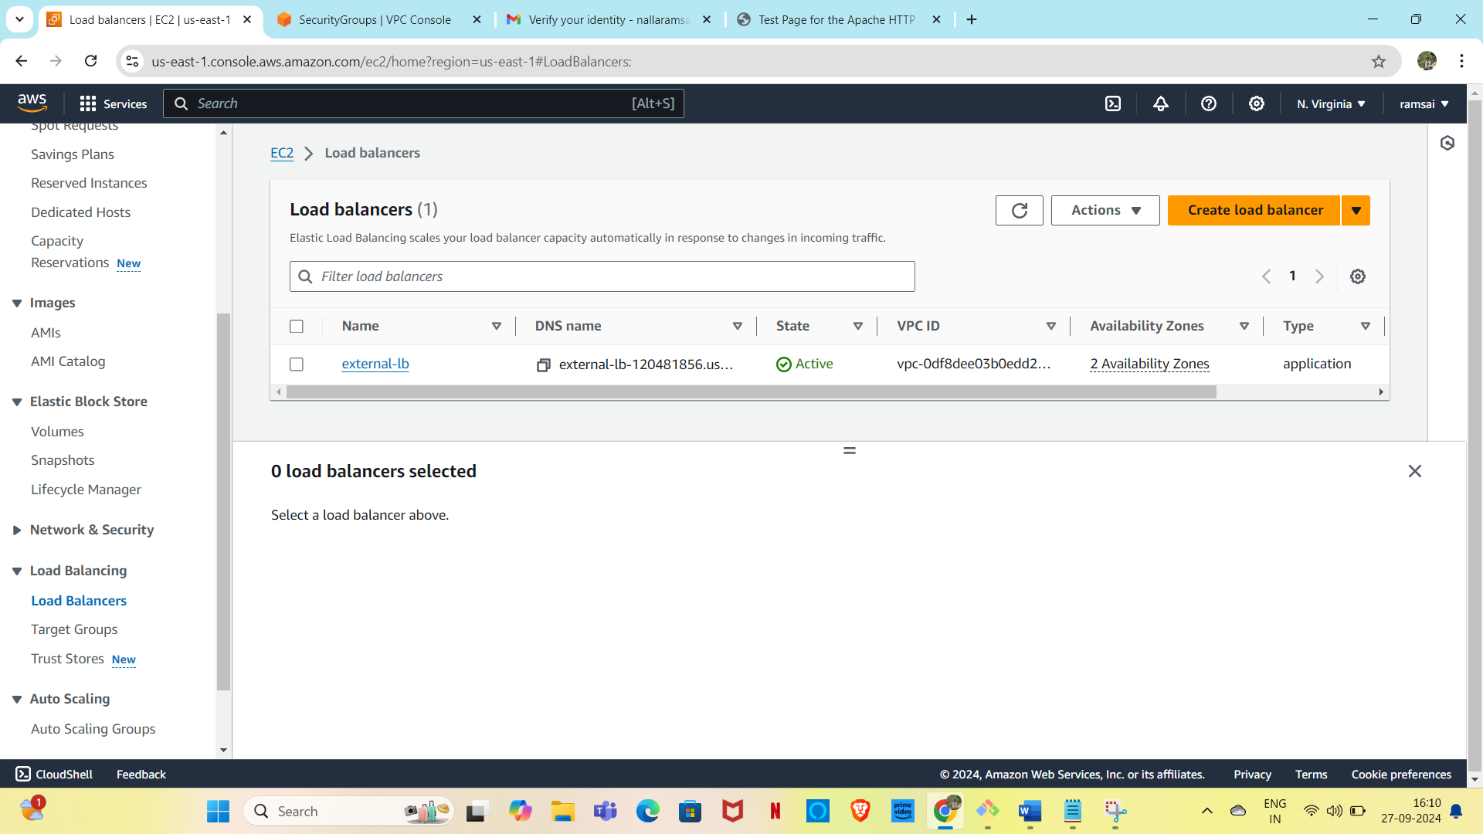

**Step-8: Create a file for the RDS instance**

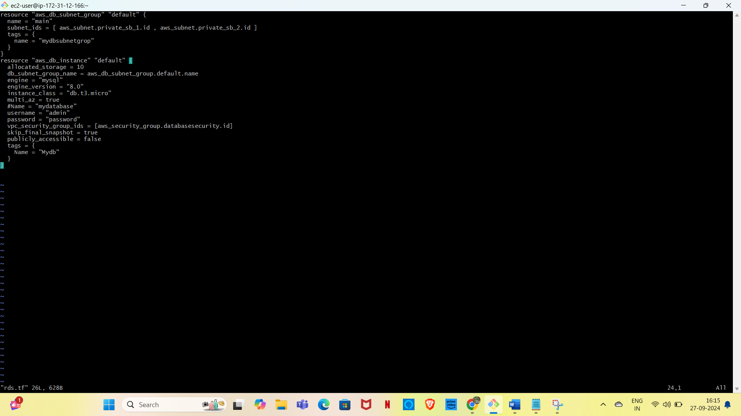

* **One database will be created in the below picture.**

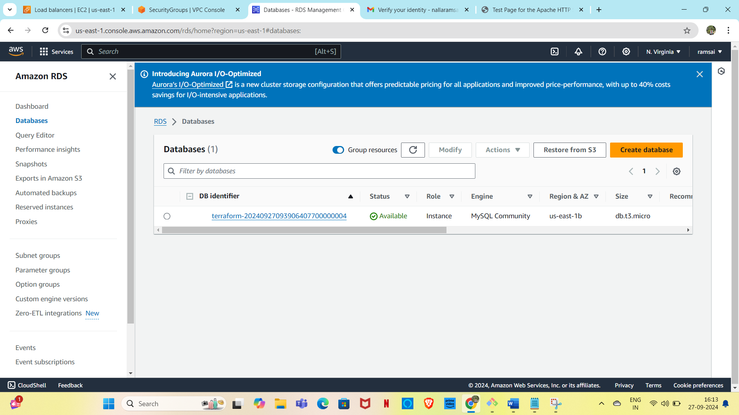

**Step-8: Create a file for outputs**



**step-9:Creating a file for variable**

* 
* **When we host the load balancers dns then we can host two websites.**

